УДК 550.837:551.24(477)
TETIANA BURAKHOVYCH¹, …………
¹Subbotin name Institute of Geophysics, NAS of Ukraine, Palladin av. 32, Kyiv, Ukraine, 03680, tel. +38(044)4512244, e-mail burahovich@ukr.net antonn@ukr.net
²Semenenko Institute of geochemistry, mineralogy and ore formation, NAS of Ukraine, Palladin av. 34, Kyiv, Ukraine, 03680, tel. +38(044)5011520, e-mail igmr@igmof.gov.ua

THE THREE-DIMENSIONAL GEOELECTRIC MODEL OF EARTH CRUST AND UPPER MANTLE OF THE DOBRUDGA REGION

Purpose. The purpose of researches is to build a three-dimensional geoelectric model of the crust and upper mantle and to answer some questions of the deep structure and geodynamics of the North Dobrudga and PeriDobrudga depression. Methodology. The methodology includes a detailed analysis of the deep structure of the region based on the results of 3D modeling of electromagnetic experimental data and to search for the interrelation between conductivity anomalies in the Earth’s crust and upper mantle and foci of seismic events. Results. Anomalies of high electric conductivity from the surface of the Earth crust to the upper mantle are identified. Stretched for hundreds of kilometers conductors are associated with deep conductive fractures of different fractures: Frunze, Saratsky, Bolgrad, Cahul-Izmail, Chadyrlungsk and others. A highly conductive layer is identified on the southern side of PeriDobrudga depression which lies at the depth corresponding to the lower crust and the top part of upper mantle. North side of PeriDobrudga depression is characterized by the distribution of electrical conductivity in the upper mantle which is the same as that of EEP, while presence of conductive structure at the depths of 110 to 160 km differs the southern slope from the northern one. Earthquake sources as well as anomalies of high electric conductivity are mainly correlated with active deep tectonic fractures and juncture zones of geological structures such as different age zones of Precambrian EEP and Cimmerian Scythian plate on the territory of PeriDobrudga depression and North Dobrudga. Originality. Three-dimensional deep geoelectric model built on experimental results of modern MTS and MVP data reflects inhomogeneous distribution of electric conductivity in the depth on the territory of PeriDobrudga depression and North Dobrudga. Practical significance. The results will make it possible to estimate more reliably the peculiarities of seismic hazard for the Dobrudga region of Ukraine and certain seismically active zones and structures. (not more than 1800 symbols)
Key words: 3D geoelectric model; conductivity anomalies; seismicity; Dobrudga. (5-8 words or word combinations)

Introduction
One of the striking manifestations of geodynamic processes of the Earth is seismicity. The works of the last decade on the seismicity are increasingly linked to issues of degassing of the Earth and, as a consequence, to the manifestation of the deep and ultradeep fluid processes in the crust and mantle of the Earth. The studied region presented, as well as all northern branch of the Eurasian belt – Dobrudga-Crimean-Caucasian, is accompanied by electrical anomalies in the crust and upper mantle [Kulik, 2009] and influences on seismicity of territory of Ukraine. Electrical resistivity is a sensitive indicator of any inner-melting or fluids processes under natural conditions which present deep in the Earth.
Tectonically the studied region belongs to the western part of the Black Sea depression [Chekunov et al, 1976], which is related to the junction of the ancient East European Platform (EEP) and a young Scythian plate (see Fig. 1). Within its boundaries there are three main zones: the North side, located on the ancient Precambrian foundation, the Southern side – on a young folded-metamorphosed Hercynian-Cimmerian foundation of the Scythian plate and the axial part of the grabens at the junction zone of platform of different ages. EEP Precambrian foundation in the axial part of the Black Sea depression connects with the pre-Black Sea suture graben, which is a deep sublatitudinally streched depression. Formation of the suture zone began in the Triassic – Jurassic period. It is a layer of Meso-Cenozoic sediments with a thickness of up to 8000 m. Suture zone includes PeriDobrudga Paleozoic (Moldovan Graben) and the North-Crimean depressions: Krylov, Odessa (Karkinitsky), Sivash. It is well known that tectonic boundaries and foundation boundaries of EEP do not coincide with each other [Hain, 2001].
One of the components of the western part of the axial zone – PeriDobrudga depression – is a complex graben-like structure made of platformal Paleozoic and Triassic-Jurassic sediments. It connects to the folded structures of Dobrudga along a series of large northwest stretching fractures.
(sections with names labeled by blue must be mandatory)
(in the "Methodology" and "Results" sections there can be additional subsections with the names, which are corresponding to its content)

Purpose
The purpose of researches is to build a three-dimensional geoelectric model of the crust and upper mantle and to answer some questions of the deep structure and geodynamics of the North Dobrogea and PeriDobrudga depression.
Methodology
The methodology includes a detailed analysis of the deep structure of the region based on the results of experimental 3D modeling of electromagnetic data and to search for the interrelation between conductivity anomalies in the Earth’s crust and upper mantle and foci of seismic events.

Results
Building of a 3D geoelectric model

Currently, the density of observations of natural electromagnetic field of an outer source at low frequencies allows us to build a three-dimensional geoelectric model of the crust and upper mantle and to answer some questions of the deep structure and geodynamics of the North Dobrudga and PeriDobrudga depression.
For calculations we use the software package of three-dimensional simulation of low-frequency electromagnetic fields, which are used in the methods of MTS and MVP – Mtd3fwd [Mackie et al, 1993, 1994]. The 3D modelling algorithm uses the integral form of Maxwell's equations to derive a finite difference approximation for the magnetic field that is second order.
A model is based on the analysis of parameters of MVP and MTS in the range of periods of magnetotelluric field of up to 4000 s [Rokityansky et al, 1979, Ingerov et al, 1988, Burakhovich et al, 1995, Burakhovich et al, 2011] (see Fig. 2).
The important element of the technique of the 3D modeling is the "normal" values of the electrical resistance (ρ_{n}) of the 1D horizontally-layered section of the earth's crust and upper mantle; it is the background of the three-dimensional geoelectric model. For the Precambrian region of the Ukrainian Shield (USh) its data are in Table 1.
Table 1.
Three-dimensional geoelectric model for the Precambrian region of the Ukrainian Shield
Depth of the range, km | ρ_{n}, Оhm⋅m | Depth of the range, km | ρ_{n}, Оhm⋅m
0–160 | 2000 | 400-500 | 20
160-200 | 600 | 500-600 | 10
200-250 | 250 | 600-760 | 5
250-320 | 100 | 760-960 | 1
320-400 | 50 | > 960 | 0.1

Hercynian-Cimmerian regions are characterized by the other values, that include "asthenosphere" – a layer of high electrical conductivity in upper mantle (see Table 2).
Table 2.
Three-dimensional geoelectric model for the Hercynian-Cimmerian region of the Ukrainian Shield
Depth of the range, km | ρ_{n}, Оhm⋅m | Depth of the range, km | ρ_{n}, Оhm⋅m
0–110 | 2000 | 400-500 | 20
110-160 | 40 | 500-600 | 10
160-200 | 600 | 600-760 | 5
200-250 | 250 | 760-960 | 1
250-320 | 100 | > 960 | 0.1
320-400 | 50

The electromagnetic parameters are significantly affected by the inhomogeneous distribution of the electrical conductivity of the subsurface conductive layer. Its total conductivity mainly corresponds to the thickness of the sedimentary deposits and correlates with the main structural geological units. North Dobrudga is characterized by relatively low values (but abrupt changes) of the total longitudinal conductivity of up to 200 Sm (see Fig. 2). In PeriDobrudga depression where the crystal base is located at a depth of about 9 km, S does not exceed 1000 Sm. On the southern slope of USh value of S reaches 1000 Sm, while on the Moldavian plate - about 100 Sm. In the Black Sea region S of the near-surface conductive layer is set in the model to be between 1000 and 2000 Sm. Distribution of electrical resistivity of the layers and their thickness in 3D model have been taken conditionally and are based on the data value of the total longitudinal conductivity of the sediments and the depths to the consolidated basement.
A great number of models with various spatial parameters of anomalous structures as well as values of electrical resistivity in the Earth's crust and the mantle were calculated. The final version of the distribution of the electrical resistivity in the depths of PeriDobrudga depression and Dobrudga is shown in Fig. 3.
Comparison of the observed and calculated induction parameters is shown only for the period of geomagnetic variations of 400 s, and the same for the MTS curves, located in different parts of the map, is shown on Fig. 2.

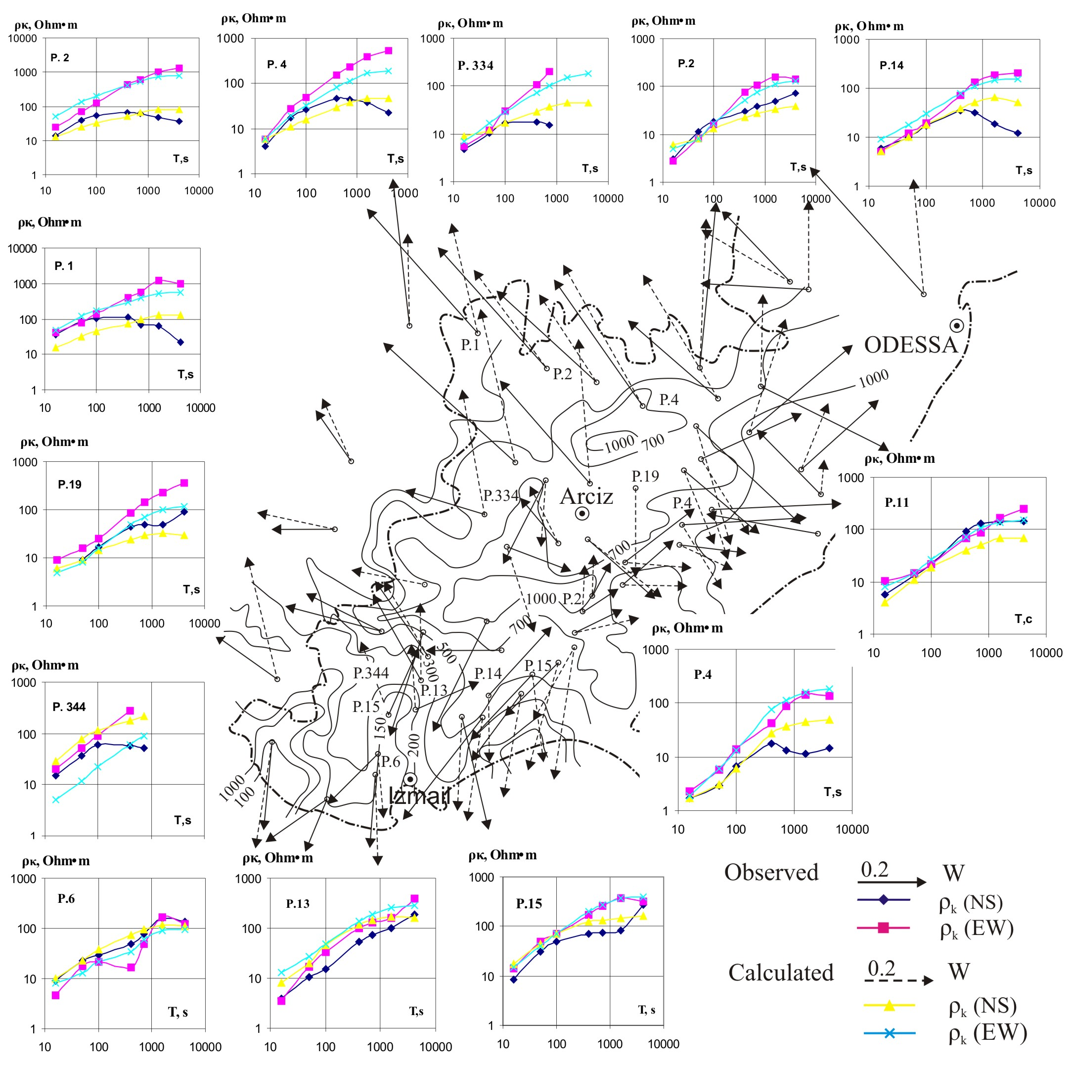
Fig. 2. Scheme of study methods МТS and MVP according to [Rokityansky et al, 1979, Ingerov et al, 1988, Burakhovich et al, 1995, Burakhovich et al, 2011]. Comparison of observed and calculated curves MTS and induction parameters for the period geomagnetic variations 400 s for the three-dimensional model presented in Fig. 3.

A three-dimensional geoelectric model
Vertical conductors from the surface to a depth of 10 km form a network of galvanically interconnected, generally elongated structures of different spatial orientations (a width of 5 to 15 km), which corresponds to the fault zones. A turn in the induction parameters space and their values indicate that the most noticeable near-surface conductivity anomalies may be related to Chadyrlung fracture, especial to the region of its intersection with Frunze, Saratsky faults and places of abrupt changes in its direction (see Fig. 2, 3).
The part of Bolgrad fracture which lies between Frunze and Saratsk fractures can be attributed to the same zones. In addition, the conductive zone (over 100 km long and 10 km wide), which changes its direction from sub-latitudinal to sub-longitudinal, is related to the junction region of Cahul-Izmailov margin suture separating Prut ledge and PeriDobrudga depression from Frunze fault. At the very top of the geoelectric cross-section at a depth of 1 km a series sub-latitudinal conductors (width from 5 to 10 km, length from 20 to 65 km) is identified. Most elongated conductors are concentrated in the axial part of PeriDobrudga depression.

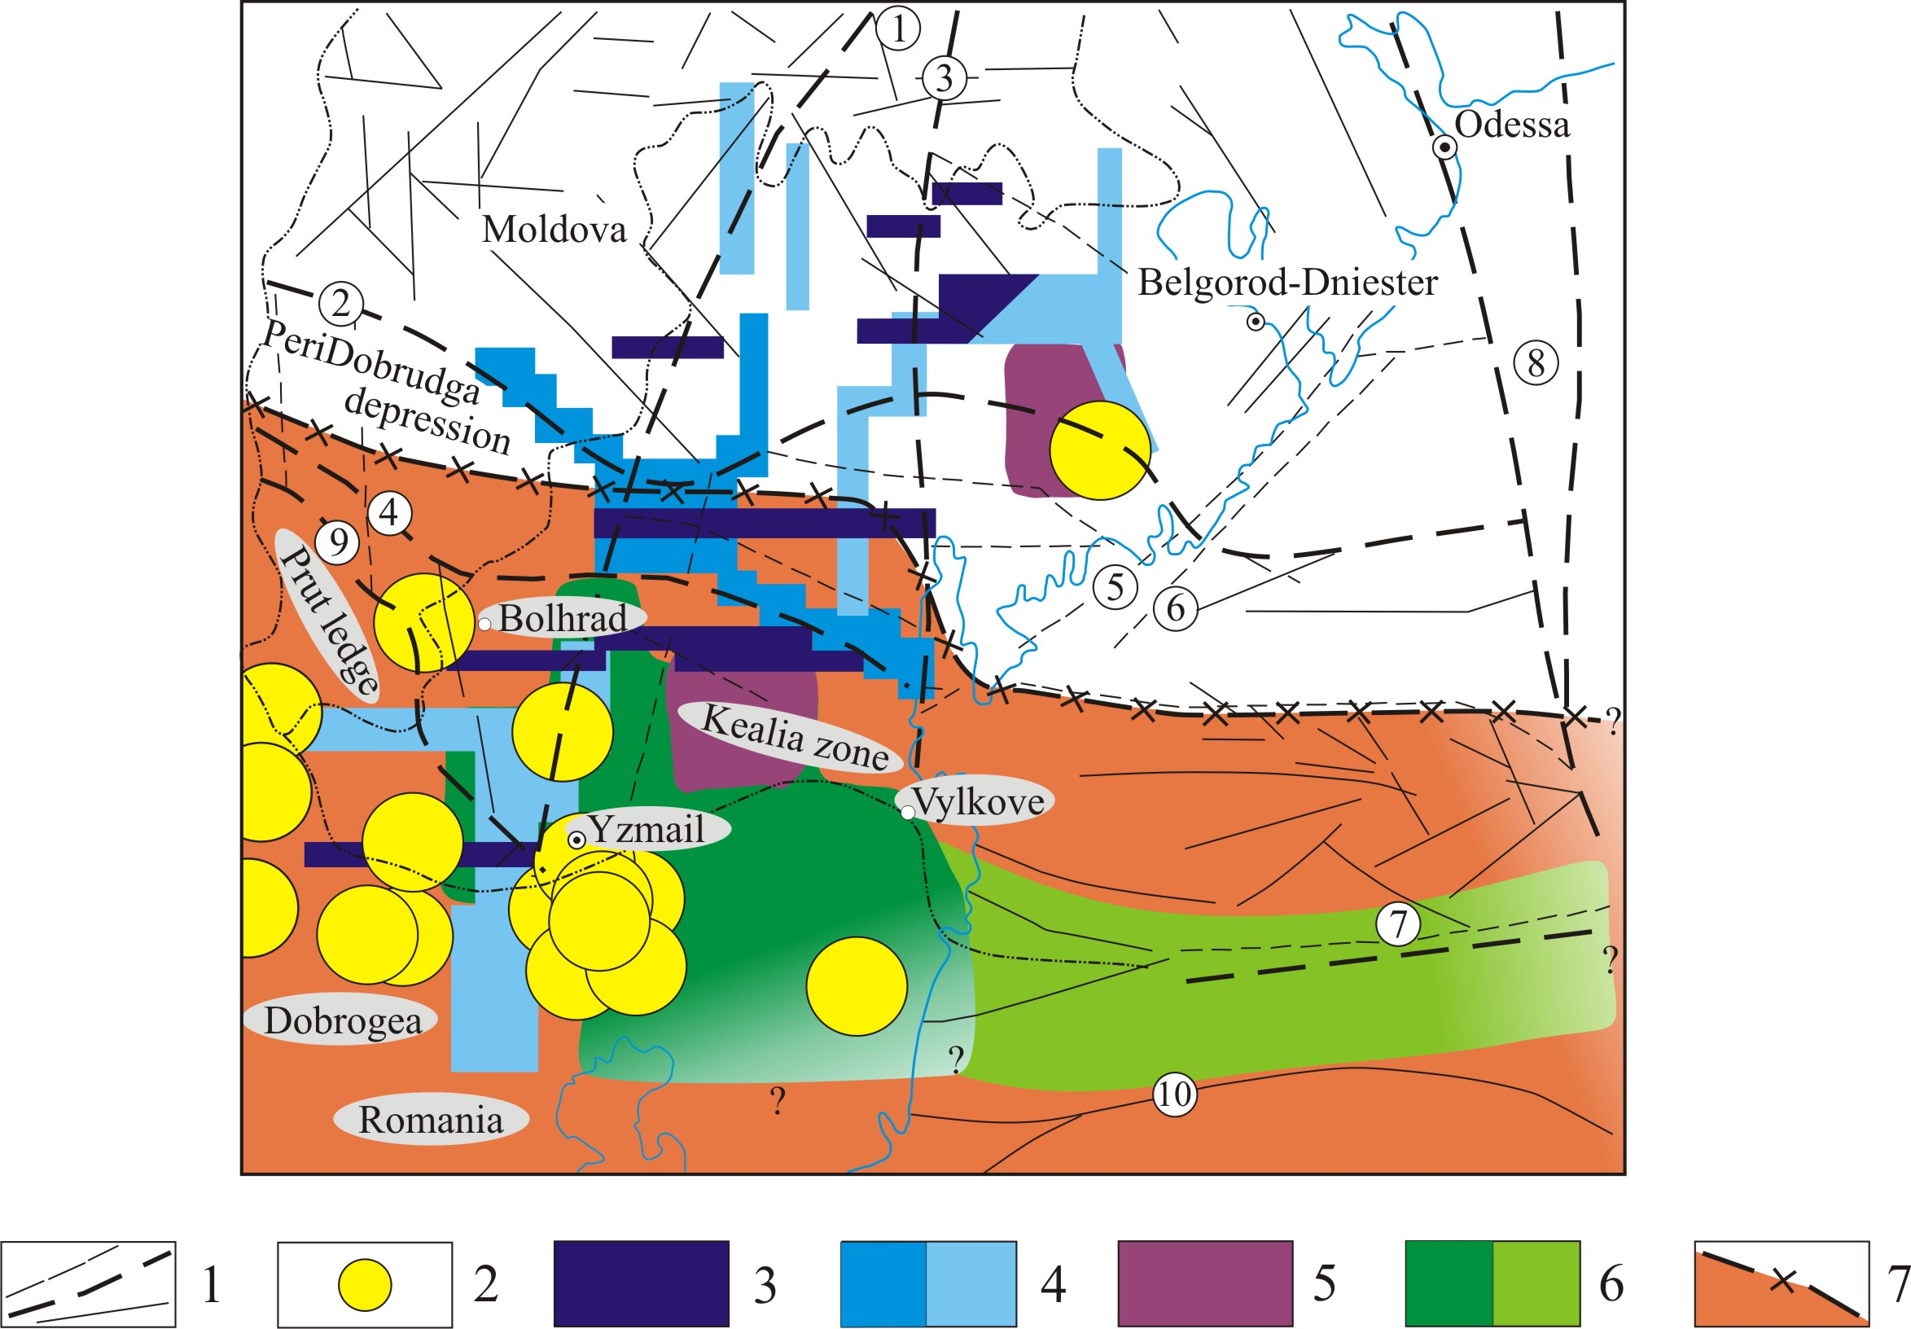

Fig. 3. The spatial location of the anomalies of high conductivity of three-dimensional geoelectric model PeriDobrudga depression and Dobrudga
1 – deep fault zones of different rank (numbers in circles): 1 – Frunze, 2 – Chadyrlunhskyy 3 – Saratsky, 4 – Bolgradsky 5 – Alibeyskyy, 6 – Black Sea, 7 – Sulina, 8 – Odessa 9 – Kahulsko-Izmayilivska; 2 – epicenters of earthquakes according to [Kutas et al, 2005]; geoelectrical parameters of conductivity anomalies: 3 – the depth of the roof and the base (h) from the surface to 1 km, ρ=2 Ohm∙m; 4 – h=1-10 km, ρ=2 Ohm∙m (a) and 10 Ohm∙m (b); 5 – h=10-40 km, ρ=10 Ohm∙m; 6 – h=40-60 km, ρ=10 Ohm∙m (a), h=20-100 km, ρ=25 Ohm∙m (b); 7 – h=110-160 km, ρ=70 Ohm∙m.

In the Earth's crust and at the top of upper mantle (from 10 to 60 km) the main conductive structure with a complex configuration is geographically related to the block that is confined between Frunze and Cahul-Izmailov (west), Saratsk (east) and Bolgrad (north) fractures on the southern slope of PeriDobrudga depression. The southern boundary is not identified. It can be assumed that it consists of two interconnected parts: top part – vertical, with small spatial dimensions, of nearly isometric shape with a diameter of up to 20 km at a depth of 10 to 40 km, and lower part – a layer with spatial dimensions from 15 to 65 km in sub-latitudinal direction and more than 90 km in sub-longitudinal direction at a depth of 40 to 60 km.
Yet another almost isometric region (15 x 25 km) of high conductivity at a depth of 10 to 40 km can be identified in the north and is related to flexure of Chadyrlung fault.
The northern boundary of the conducting layer in the upper mantle at a depth of 110 to 160 km stretches in sub-latitudinal direction and is geographically located between Chadyrlung and Bolgrad faults. Along Saratsk fault the boundary shifts by 30 km to the south, where it probably extends further in sub-latitudinal direction in the Black Sea basin.
Island Zmeinyy, and also Zmiinoostrivne and Vilkivske of raising on depths a 20-100 km in a cut show up as an electro conductive structure, which is expressed a sub-latitudinal conductor that occupies intermediate position between faults of Pechenga-Kamena on a south and Kiliyskim оn the north.
In this way the territory of North Dobrudga and PeriDobrudga depression, as well as the whole south-western margin of the EEP, is rich in anomalous objects of high electrical conductivity in the Earth's crust, and the distribution of electrical conductivity in the upper mantle reflects the location of the junction between the ancient EEP and young Scythian plate.

Manifestation of seismicity in the territory
of Northern Dobrudga and PeriDobrudga depression

According to many seismologists [Kutas et al, 2005, Drumea et al, 1964, Pustovitenko et al, 2006, Nikonov and Nikonova, 1990] the territory of North Dobrudga and PeriDobrudga depression is seismically poorly studied. Throughout historic times several earthquakes with a magnitude of M=3.5-7.0 with intensity of >5 points in the epicenter [Nikonov and Nikonova, 1990] are known. According to various sources, the intensity of the shocks reaches 6 [Pustovitenko et al, 2006] and 7-8 points [Drumea et al, 1964]. Earthquake foci are located at depths ranging from 0 to 35 km or more. According to [Kutas et al, 2005] the most earthquake-prone areas are (see Fig. 3) intersection of the boundary suture that follows PeriDobrudga depression from the north (Chadyrlungsk) and south (Cahul, Ismail) with a regional mantle sub-longitudinal faults – Frunze and Saratsk. In addition, a seismically active zone is Chadyrlungsk boundary suture (Artsyz part), fragmented by breaking of fractures of a lower rank – Alibeysk and the Black Sea.
Earthquakes epicenters in North Dobrudga (Tulcea, Izmail, Reni, Kealia) are concentrated on the border of a shallow (1-10 km) high conductivity anomaly (ρ=10 Ohm·m) which coincides geographically with the location of Frunze fault and its intersection with Cahul-Izmail suture. Foci of these seismic events are located above the full-scale anomaly of high conductivity at a depth of 40 to 60 km, ρ=10 Ohm·m.
Epicenters of earthquakes on the northern slope of PeriDobrudga depression also coincide with the location of the anomaly of high electrical conductivity of complex configuration at the depth range between 1 and 40 km, ρ=2-10 Ohm·m (see Fig. 3).
Thus, earthquakes occur on both sides of the boundary of anomalous distribution in the upper mantle of the junction of the ancient EEP and young Scythian plate. However, the majority of them are observed in the region of concentration of conductivity anomalies at different depths from 1 to 40 km.
PeriDobrudga depression belong to the border zone of the mantle under the EEP, distinguished by the changes of zero isoline of velocity discrepancies with the depth within the limits of the upper mantle and its transition zone according to the data of 3-D P – velocity model [Tsvetkova and Bugaenko, 2012, Bugaenko et al, 2008]. Mantle boundary zone corresponds to a system of inclined layers. Special features of mantle velocity structure under PeriDobrudga and North-Crimean depressions and its surroundings made possible to partition mantle prerequisites of seismicity of the area under consideration related to manifestation of mantle plume in the lower and medium mantle. The spatial location of the electrical conductivity anomalies corresponds to the manifestation of sub-vertical mantle columns in the range of 28-30⁰ E x 45-46⁰ N.
Originality
Three-dimensional deep geoelectric model built on experimental results of modern MTS and MVP data reflects inhomogeneous distribution of electric conductivity in the depth on the territory of PeriDobrudga depression and North Dobrudga.
Practical significance
The results will make it possible to estimate more reliably the peculiarities of seismic hazard for the Dobrudga region of Ukraine and concrete seismically active zones and structures.
Conclusions
Anomalies of high electric conductivity from the surface of the Earth crust to the upper mantle are identified. Stretched for hundreds of kilometers conductors are associated with deep conductive fractures of different ranks and with their intersections: Frunze, Saratsky, Bolgrad, Cahul-Izmail, Chadyrlungsk fractures and others. A highly conductive layer is identified on the southern side of Peridobrudga depression and lies at the depth corresponding to the lower crust and the top part of upper mantle. North side of Peridobrudga depression is characterized by the distribution of electrical conductivity in the upper mantle which is the same as that of EEP, while presence of conductive structure at the depths of 110 to 160 km differs the southern slope from the northern slope.
Without a doubt, there is a relationship between seismicity and geoelectric parameters that reflect the current state of the Earth's interior. The origin of high electric conductivity anomalies may be the result of geodynamic processes on the boundaries of regions characterized by various manifestations of these processes.
Earthquake sources as well as anomalies of high electric conductivity are mainly correlated with active deep tectonic fractures and juncture zones of geological structures such as different age zones of Precambrian EEP and Cimmerian Scythian plate on the territory of PeriDobrudga depression and North Dobrudga.
References
Bugaenko, I. V., Shymlanskaya, L. A., Zaets, L. N., Tsvetkova T. A. (2008). Three-dimensional P-velocity model of the mantle of the Black Sea and adjacent territories. Geophys. Journal, 5(30), 145–160 (in Russian).
Drumea, A. V., Ustinova, T. I., Schukin, J. K. (1964). Problems of tectonics and Seismology of Moldova. Kishinev, “Karty Modvii” Publ. (in Russian).
Kulik, S. N. (2009). The northern branch of the Eurasian conductivity anomalies. Geophys. Journal, 4(31), 168–180 (in Russian).

Examples of bibliography (References) on the site…
http://science.lpnu.ua/jgd/instructions-authors
(not less than 13 positions in the “References” (no more than 35), not less than half of them not older than 2000; not less than 5 positions non-cyrillic (in origins) of the rating journals)

(For authors from other countries, informational bloc in Ukrainian will not be required (will be added in the editorial board)

Т. К. БУРАХОВИЧ¹, А. М. КУШНІР¹, І. Ю. НІКОЛАЄВ², Б. І. ШИРКОВ¹
¹Інститут геофізики ім. С. І. Субботіна НАН України, Палладіна пр. 32, 03680, Київ, Україна, тел. +38 (044) 4512244, електронна пошта burahovich@ukr.net antonn@ukr.net
²Інститут геохімії, мінералогії та рудоутворення ім. М. П. Семененка НАН України, Палладіна пр. 34, 03680, Київ, Україна, тел. +38 (044) 5011520, електронна пошта igmr@igmof.gov.ua

ТРИВИМІРНА ГЕОЕЛЕКТРИЧНА МОДЕЛЬ ЗЕМНОЇ КОРИ ТА ВЕРХНЬОЇ МАНТІЇ ДОБРУЗЬКОГО РЕГІОНУ

Мета. Метою досліджень є створення тривимірної геоелектричної моделі земної кори та верхньої мантії та отримання відповідей на деякі питання глибинної будови і геодинаміки Північної Добруджі та Перед-Добрузького прогину. Методика. Методика включає в себе докладний аналіз глибинної будови регіону на основі результатів моделювання 3D експериментальних електромагнітних даних і пошуку взаємозв'язків між аномаліями електропровідності в земній корі і верхній мантії та вогнищами сейсмічних подій. Результати. Виявлено аномалії високої електропровідності на глибинах від поверхні до вехньої мантії. Витягнуті на сотні кілометрів аномалії високої електропровідності приурочені до глибинних розломів різного рангу та їх перетинів: Фрунзенського, Саратського, Болградського, Кагульско-Ізмаїльського, Чадирлунгського та інших. Високопровідний шар складної конфігурації виділяється на Південному борті Перед-Добрузького прогину та залягає на глибинах, які відповідають нижній корі та верхам верхньої мантії. Північний борт Перед-Добрузького прогину характеризується розподілом електропровідності у верхній мантії таким же, як у надрах СЄП, в той час як Південний відрізняється від Північного наявністю високопровідної структури на глибинах від 110 до 160 км. Вогнища землетрусу, як і аномалії високої електропровідності, в основному, корелюють з активними глибинними тектонічними розломами та зонами зчленування геологічних структур, такими, якими є різновікові докембрійська СЄП та кіммерійська Скіфська плита на території Добрузького регіону. Наукова новизна. Тривимірна геоелектрична модель, побудована за сучасними експериментальними результатами МТЗ та MВП, відображає неоднорідний розподіл електричної провідності в глибині на території Перед-Добрузького прогину та Північної Добруджі. Практична значимість. Результати досліджень дадуть можливість більш надійно оцінювати особливості сейсмічної небезпеки для Добрузького регіону України та конкретних сейсмоактивних зон і структур.
Ключові слова: 3D геоелектричні моделі; аномалії електропровідності; сейсмічність; Добруджа.

(the total volume of the article from 8 to 18 pages)

