Olena Stankevych¹, Dariia Rebot²
¹ Computer Design Systems Department, Lviv Polytechnic National University, Ukraine, Lviv, S. Bandery street 12, E-mail: olena.m.stankevych@lpnu.ua, ORCID 0000-0003-3431-1213
² Computer Design Systems Department, Lviv Polytechnic National University, Ukraine, Lviv, S. Bandery street 12, E-mail: dariya.p.rebot@lpnu.ua, ORCID 0000-0004-7890-0987
INTERACTIVE SYSTEM OF SURFACE WATER MONITORING USING
IoT TECHNOLOGIES
Received: August 12, 2023 / Revised: September 28, 2023 / Accepted: November 01, 2023
© Stankevych O., Rebot D., 2023
Abstract. Place here an abstract in English or in Ukrainian (within the range of 250-500 words). The abstract should briefly present the purpose, principal results and novelty of your research and should contain the following elements: problem statement, purpose, methodology, findings (results), originality (novelty), practical value, scopes of further investigations. An English abstract is attached at the end of the publication for Ukrainian articles.
Keywords: you should add from 6 to 10 keywords. The index terms should represent the whole paper content.

Introduction
In order of effect high quality of “Computer Design Systems. Theory and Practice” journal, the authors are requested to follow instruction given in this sample paper. The Editorial Board recommends to prepare paper in MS Word using this template style set.

Problem Statement
The volume of papers should not be less than 8 pages (including figures and references). All figures must be stored in *.tiff or *.jpg format with the minimum resolution of 300 dpi and sent in attachment together with the paper.

Review of Modern Information Sources on the Subject of the Paper
The Times New Roman 11 pt font should be used for main text with line spacing 1.1.
The text have to be prepared in one column. The paragraph indent should be 10 mm. The page margins and size are given in Table 1. Tables should be placed as separate objects with dimensions which do not exceed the page size. Before the table, the numbering title (for example, Table 1) should be typed in one line and in the next line, the name (title) of the table should be typed.
Table 1
Page layout description
Paper size | А4 (210x297 mm)
Inside margin | 18 mm
Outside margin | 25 mm
Top margin | 20 mm
Bottom margin | 25 mm
Author's names (without affiliation) should be typed in the top of the page using 11 pt bold font. Author's affiliation (institution, address, e-mail) should be given using 11 pt font. The spacing between authors line and affiliation line is 6 pt. The article title must be written using 14 pt, bold, сentered font. The spacing before and after the title line are respectively 6 pt. and 12 pt.

Objectives and Problems of Research
In the beginning of the paper, the abstract and keywords should be given. The abstract should be within the range of 250-500 words. Please, use 11 pt font for abstract and for keywords.
Paper text has to be divided into a number of sections (recommended sections – Introduction, Problem Statement, Review of Modern Information Sources on the Subject of the Paper, Objectives and Problems of Research, Main Material Presentation, Results and Discussion, Conclusions, References). Section titles should be typed using 11 pt centered bold font. The spacing between last section and next section title should be 6 pt, between section title and corresponding section – 3pt.

Main Material Presentation
Equations should be prepared in Microsoft Equation or Mathtype software centered and labelled. The example of equation is Eq. 1:
$ω_{k}(a)={αa}^{ν}\frac{{kΠ}_{x}}{l}$, | (1)
where $ω_{k}(a)$ the frequency of oscillation of the elastic element; $α$ - a parameter that takes into account the physical and mechanical characteristics of an elastic element.
Font sizes in formulas should be as follows: Full – 11 pt, Subscript/Superscript – 9 pt, Sub- Subscript/Superscript – 7 pt, Symbol – 14 pt, Sub-symbol – 11 pt. Larger equations must be split in multiple lines.
Results and Discussion
All figures must be stored in *.tiff or *.jpg format with the minimum resolution of 300 dpi. Each figure must have a caption under the figure. For figure captions 10 pt font should be used.
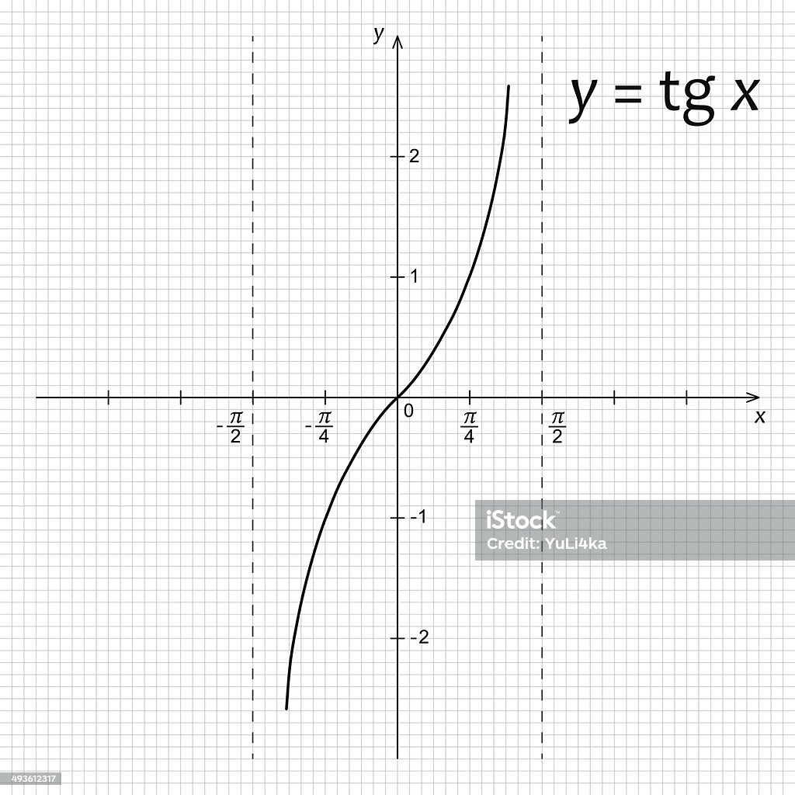
Fig. 1. Diagram of mathematical function
When your refer to an equation, a figure, a table, a section or literature references in the text of the paper please, please, use the following expressing: Eq. (1), Eqs. (1) and (2); Fig. 1, Figs. 1 and 2; Table 1, Tables 1 and 2; Section 1, [1], [2], [1] – [4].

Conclusions
In this paper, the instructions for preparing camera ready paper for “Computer Design Systems. Theory and Practice” journal are presented.
Proper references formatting is essential for scientific papers inclusion in the bibliographic databases such as SciVerse Scopus and Web of Science. References should be in English only and laid out according to IEEE style requirements using 10 pt font. The list of information sources on the subject of the article should include at least 10 references. It is recommended to cite scientific works of local and foreign authors published in journals that are included in the international scientometric databases. All titles in Ukrainian and other languages using non-Latin characters should be transliterated into Latin characters:
- names of authors – transliteration;
- titles of papers, books and websites – transliteration with adding English translation in square brackets (e.g. “Neorganichnya khimiia” [“Inorganic chemistry”]);
- titles of journals and other periodicals – transliteration with adding English translation in square brackets (e.g. Zhurnal informatsiinykh tekhnolohii [Journal of information technologies]);
- conference titles – transliteration with adding English translation in square brackets (e.g. Trudy 6 Mezhdunarodnogo Simpoziuma “Novye resursosberegayushchie tekhnologii nedropol'zovaniya i povysheniya neftegazootdachi” [Proc. 6th Int. Symp. “New energy saving subsoil technologies and the increasing of the oil and gas impact”]);
- publishers titles – transliteration with adding word “Publ.” (e.g. Vydavnytstvo Lvivskoi politekhniky Publ.).

Acknowledgements
Please, place here the title and number of the project, in terms of which the presented results were obtained and Acknowledgements to the organizations and/or people contributing to or sponsoring the project (at the discretion of the author).

References
1. Books referring
Basic Format:
[1] J. K. Author, “Title of chapter in the book”, in Title of the Published Book, xth ed. City of Publisher, Country if not USA: Abbrev. of Publisher, year, chapter x, section x, pp. xxx–xxx.
2. Conference Technical Articles referring
Basic Format:
[8] J. K. Author, “Title of paper”, in Unabbreviated Name of Conf., City of Conf., Abbrev. State (if given), year, pp. xxx–xxx.
3. Patents referring
Basic Format:
[11] J. K. Author, “Title of patent,” U.S. Patent x xxx xxx, Abbrev. Month, day, year.
4. Standards referring
Basic Format:
[14] Title of Standard, Standard number, date.
5. Dissertations (Ph.D., Sc.D.) referring
Basic Format:
[17] J. K. Author, “Title of dissertation”, Ph.D. dissertation, Abbrev. Dept., Abbrev. Univ., City of Univ., Abbrev. State, year.
6. Periodicals referring
Basic Format:
[21] J. K. Author, “Title of the paper”, Abbrev. Title of Periodical, vol. x, no. x, pp. xxx-xxx, Abbrev. Month, year.
Examples:
[1] G. Eason, B. Noble, and I. N. Sneddon, “On certain integrals of Lipschitz-Hankel type involving products of Bessel functions,” Phil. Trans. Roy. Soc. London, vol. A247, pp. 529–551, April 1955. (references)
[2] J. Clerk Maxwell, “A Treatise on Electricity and Magnetism,” 3rd ed., vol. 2. Oxford: Clarendon, 1892, pp.68–73.
[3] I. S. Jacobs and C. P. Bean, “Fine particles, thin films and exchange anisotropy,” in Magnetism, vol. III, G. T. Rado and H. Suhl, Eds. New York: Academic, 1963, pp. 271–350.
[4] K. Elissa, “Title of paper if known,” unpublished.
[5] R. Nicole, “Title of paper with only first word capitalized,” J. Name Stand. Abbrev., in press.
[6] Y. Yorozu, M. Hirano, K. Oka, and Y. Tagawa, “Electron spectroscopy studies on magneto-optical media and plastic substrate interface,” IEEE Transl. J. Magn. Japan, vol. 2, pp. 740–741, August 1987 [Digests 9th Annual Conf. Magnetics Japan, p. 301, 1982].
[7] M. Young, “The Technical Writer's Handbook. Mill Valley,” CA: University Science, 1989.

Олена Станкевич¹, Дарія Ребот²
¹ Кафедра систем автоматизованого проектування, Національний університет Львівська політехніка, вул. С. Бандери 12, Львів, Україна, E-mail: olena.m.stankevych@lpnu.ua, ORCID 0000-0003-3431-1213
² Кафедра систем автоматизованого проектування, Національний університет Львівська політехніка, вул. С. Бандери 12, Львів, Україна, E-mail: dariya.p.rebot@lpnu.ua, ORCID 0000-0004-7890-0987
ІНТЕРАКТИВНА СИСТЕМА МОНІТОРИНГУ ПОВЕРХНЕВИХ ВОД З ВИКОРИСТАННЯМ ТЕХНОЛОГІЇ ІОТ
Отримано: Серпень 12, 2023 / Переглянуто: Вересень 28, 2023 / Прийнято: Листопад 01, 2023
© Станкевич О., Ребот Д., 2023
Анотація. Розмістіть тут анотацію українською мовою (в межах 250-500 слів). Анотація повинна стисло викладати мету, основні результати та новизну Вашого дослідження та містити наступні елементи: постановку проблеми, мету, методологію, висновки (результати), оригінальність (новизна), практичне значення, масштаби подальших досліджень. Для українських статей у кінці видання додається анотація англійською мовою.
Ключові слова: необхідно додати від 6 до 10 ключових слів. Терміни покажчика мають представляти весь вміст статті.

